**Bukidnon State University, Alubijid External Studies Center**

**Alubijid, Misamis Oriental**

**Online Supply Inventory System**

In Partial Fulfillment of the Requirements

For the Degree of

Bachelor of Science in Information Technology

Proponents :

Abriol, Ariel O.

Maglangit, Erbie Valerie N.

Abellanosa, Rolly B.

.

Presented to:

Mr. Patrick D. Doldolea

Instructor

**TABLE OF CONTENTS**

Title Page Pages

Acknowledgment i

Project Title ii

Background of the Study iii

Chapter I: Introduction

1.1 Statement of the Problem................................................................................1

1.2 Objectives........................................................................................................1

1.3 Project Concept .….........................................................................................2

1.4 Project Vision …..............................................................................................2

1.5 Relevance of the Study …...............................................................................3

1.6 Scope and limitation …....................................................................................3

1.6 Definition of terms... …....................................................................................4

Chapter II: Review of Related Literature.........................................................................

Chapter III: Methodology

3.1 Setting of the Study ... ….................................................................................5

3.2 Requirements Definition ... …..........................................................................5

3.2.1 Functional Requirement ... …............................................................5

3.2.2 Non-Functional Requirement... ….....................................................5

3.2.2.1 Performance Requirement... …...........................................5

3.2.2.1.1 Hardware and Software Requirement….............6-8

3.2.2.2 Information Requirement ... ….............................................9

3.2.2.3 Economic Requirement ... …...............................................9

3.2.2.4 Control and Security Requirement ... …...............................9

3.2.2.5 Efficiency Requirement ... …..............................................10

3.2.2.6 Service Requirement ... ….................................................10

3.3 Business Constraints ... ….............................................................................10

3.4 Technology Constraints ... ….........................................................................10

3.5 Project Strategy ….........................................................................................10

Chapter IV: Presentation, Analysis and Interpretation of Data

4.1 Justification of the Proposed System ... …....................................................11

4.2 Proposed Organizational Chart ... ….........................................................none

4.3 Proposed Context Level Diagram ... ….........................................................11

4.4 Proposed Diagram 0 ... ….............................................................................12

4.5 Child Diagram …......................................................................................13-14

4.6 Entity Relation Diagram (ERD) …………………………………………………15

4.7 Data Flow Diagram...…............................................................................16-17

4.8 Database Design ...…....................................................................................18

4.9 Data Dictionary...…........................................................................................19

4.10 Process Specification Format ...…...............................................................20

4.11 Proposed Implementation Code ...…...........................................................20

Chapter V: Project Feasibility

5.1 Technical Feasibility ...…...............................................................................21

5.2 Economic Feasibility ..…................................................................................21

5.3 Operational Feasibility ...…............................................................................22

5.4 Legal Feasibility ...…......................................................................................22

5.5 Schedule Feasibility ...…...............................................................................22

Chapter VI: Financial Feasibility and Cost Benefits Analysis

6.1 Existing Operational Cost (Supplies and Materials Annually) …...................23

6.2 Proposed Operational Cost (Supplies and Material) ….................................23

6.3 Annual Benefits and Development Cost …....................................................24

6.4 Payback Period..............................................................................................24

Appendix A

1. Summary..........................................................................................................25

2. Conclusion ......................................................................................................25

3. Recommendation.............................................................................................26

4. Definition of Terms...........................................................................................26

5. Bibliography.....................................................................................................27

6. Interview Questions.........................................................................................27

Appendix B

1. Time Table.......................................................................................................28

2. Gantt Chart......................................................................................................28

3. PERT Diagram.................................................................................................29

4. Flow Chart .................................................................................................30-34

5. Screen shots...............................................................................................35-38

6. Sample Reports...............................................................................................

7. Sample Coding................................................................................................

i

**ACKNOWLEDGEMENT**

We sincerely acknowledge the support of the people who have taken part in the achievement of this project. Without their encouragement, inspiration and support we cannot finished this project.

To our parents for their untiring supports in sending us to school, for their guidance and efforts not just financially but also in emotional, moral and spiritual aspects have become our strengths in striving hard on our studies.

To our classmates, especially to our Instructor Mr. Patrick E. Doldolea for the time, wisdom and knowledge he had given on us that was imbued to equip us with the things that we will be needed in facing the challenges of our life and welcome us to the world of knowledge.

And to our Almighty God for without Him all these are nothing.

ii

**Online Supply Inventory System**

iii

**Background of the Study**

Inventory management is a prime task for an organization to achieve its goals of maintaining appropriate level of inventory and minimizing waste. A web-based system of managing inventory in a university setting is expected to help various facilities keep an update on the status of their tools and equipment. In this study, a model is presented for putting an online supply inventory system in place in different of Bukidnon State University, Alubijid External Studies Center. In designing such a system, PHP has been employed as a development language and MySQL as a backend database with CSS implemented for the interface. Two screen-shots have been illustrated to offer a glimpse of the proposed web-based system and its applications.

This online supply inventory system would help the personnel in charge of the supply office find out the capacity of the supplies as well as the relevant information of asset availability, and replace the current practice of extensive manual recording of asset documentation thus holding a key for an organization like university to gaining competitive advantage through efficient operational performance.

**Chapter I**

**Introduction**

Inventory system deals primarily with determining the size and placement of the materials within a facility or within multiple locations of a supply chain network. It is also concerned with the importance of forecasting the required inventory, availability of physical space, and cost in carrying those inventories to maintain the planned course of production against the random fluctuations, or shortage of materials. One way of managing inventory is to have a web-based system in place that can instantly track and update the information about the tools or equipment.

The importance of implementing a web based inventory system is becoming vital as most of the time the information are accessible instantly, thereby making the details of the usage of the equipment available, and improving the movement and anticipation of their demand as well as the productivity of the system as a whole. The implementation of this web-based inventory system can help institutions develop the skills to cope with their operational environments. Because lack of system tool to be used to monitor the availability and quantity of materials in this university.

1

**1.1 Statement of the Problem**

**General Problem:**

Bukidnon State University, Alubijid External Studies Center (AESC) Supply Office Inventory System is using manual system on the inventory of all the properties of university.

**Specific Problem:**

They are using MS Excel in their inventory to record the properties of the university.

* They could not easily track down the properties of the university.
* Redundancy in entering items.
* It takes much time in making their inventory

**1.2 Objectives**

**General Objectives**

To develop an efficient and fast computer-based inventory system in Bukidnon State University, Alubijid External Studies Center (AESC) Supply Office.

**Specific Objectives**

* Shorten data-processing time

In processing the inventory, it will not consume enough time to process.

* Reduce errors

Through this system, fewer errors will be avoided because the system will be easy to use.

* Improve the accuracy of input

It will help the user to avoid mistakes regarding the data that they will give to the clients. There will be accurate information.

2

* Give information easily and efficiently

It will make easier for the user to give information to the faculty.

* Data integrity

It gives users the assurance that the information they see is trustworthy.

* Data security

It ensures that [data](http://en.wikipedia.org/wiki/Data) is kept safe from [corruption](http://en.wikipedia.org/wiki/Data_corruption) and that access to it is suitably [controlled](http://en.wikipedia.org/wiki/Access_control). Thus data security helps to ensure [privacy](http://en.wikipedia.org/wiki/Data_privacy). It also helps in protecting personal data.

**1.3 Project Concept**

The proponents have come with the idea of the project because many of the faculties in Bukidnon State University Alubijid External Studies Center have observed that the Inventory system rely on manual process of giving information on the properties of the university. Many of the faculties also observed and complained that the processing of their information is time consuming.

Then the proponents have decided to propose a computerized information system in the Supply Office of Bukidnon State University Alubijid External Studies Center, Alubijid, Misamis Oriental in order to improve and develop their system and to track the properties of the university more responsive to the needs and desires of the faculties.

**1.4 Project Vision**

The Bukidnon State University Supply Officer wants to make the inventory system more responsive to the needs and desires of the faculties by making manual system a computerized one. They want to have a system that will help reduce files, paper works and delays in computer processing.

3

The system could provide limited access to ensure data security and the data is protected. They also recommended to effectively and efficiently tracking the properties of the school.

**1.5 Relevance of the Study**

Nowadays, institutions particularly at Bukidnon State University,Alubijid External

Studies Center, AlubijidMisamis Oriental are looking for improvement of the Supply Office for their system to reach and achieve their goals and objectives as successful institutions. The relevance why the proponents have to conduct the study is:

* To understand how institutions work to design an appropriate computerized system
* To enhance the service offered by the institutions

This study will be advantageous not only to the management but also for the faculties and staffs and individuals involved in their information. This includes the following:

* Faculties/Staffs - this will help minimize their tasks and speed up the processing of information.
* Management – through this system study, the management will be able to evaluate or assess the performance of the currently used system and be able to find out the common problems that arise.

**1.6 Scope and Limitation**

This study limits only in the process of inventory system of the Bukidnon State Universtiy, Alubijid External Studies Center supply office which is located at Poblacion, Alubijid, Misamis Oriental.

The possible people that can use the system would be the following:

4

* **Principal**- the center administrator of a school. He has the authority to operate the system; he can open it if he has transactions to do.
* **Supply Officer** – the person assigned to manage the properties of the university; he/she have also the authority to operate the system; he/she is the one that will make the inventory of the property of the university.
* Other people that would be given the authorization.

**1.7 Definition of Terms**

* **Inventory**- is the process of making an itemized list of supplies on hand.
* **Inventory system**- is the system of recording the properties of the school in supply office
* **Faculty’s information**- faculty’s background
* **Data loss**-refers to the unforeseen loss of data or information.
* **Data Security**- extrusion prevention is the practice of stopping data leakage by filtering outbound network traffic. The practice protects sensitive digital assets from unauthorized transfer by stopping the movement of packets across the network. Extrusion detection, by contrast, simply alerts an administrator to a potential issue.
* **Data Integrity**- refers to the validity of data, meaning data is consistent and correct.

**Chapter II**

**Review of Related Literature**

Keeping records and inventory numbers by paper are a thing of the past. With doing that you can't have up to date accurate numbers and by not having up to date accurate numbers it can make your day a little more challenging then it normally should be. In today’s society everything is about the now, and with the now comes new technology. We all know that paper records are not anything new it is an old habit that needs to be broken.

Bukidnon State Universtiy Supply Office is an office which is a part of the school that supplies books and other supplies that the school needed.

Since BSU Supply Office has a computer which they use to make inventories using MS Excel, we offered them our proposal of improving their inventory method. We call our project proposal “Advance Inventory System” because the office already have already a computerized system, as mentioned earlier. Using MS Excel in doing inventories is much like doing it on paper but it is much easier because you won’t be writing on a bunch of papers.

An inventory system is a complete system that performs functions such as transactions (borrowing of books/supplies). For the reason the system guides them through the creation of faculty list, supplier list, book and supplies list. The system can track down supply items, remaining stocks and incoming stocks.

**Chapter III**

**Methodology**

5

**3.1 Setting of the Study**

The study was proposed for the inventory transaction of the Supply Office of Bukidnon State University, Alubijid External Studies Center located at Alubijid, Misamis Oriental.

**3.2 Requirements Definition**

**3.2.1 Functional Requirement**

There are several functions that are included in the system to satisfy the needs of the university. Some of these are as follows:

The proposed system is intended for inventory purposes. Thus, it can perform different processes included in the inventory. It will be able to monitor the supply of a certain items; the newly ordered items will be added to the current stocks and for the outgoing stocks that can be subtracted from the current stock. Therefore, the university will able to track the item/supply that are running out of stock and thus prepare order. It can also monitor faculty’s orders, and purchases from supplier.

**3.2.2 Non – Functional Requirement**

**3.2.2.1 Performance Requirement**

The system would require the hardware and software specification stated below to maximize its performance. If the specified requirements are not provided by the university, the system will not satisfy the institution expectation on the system.

Aside from the hardware and software specification, the system also requires a user that is capable of navigating the system well. And it’s not necessary that the user types very fast, even if it is just the average speed as long as it can manage the system well.

6

**3.2.2.1.1 Hardware and Software Requirement**

The proposed system will work on Firefox V5.3 or higher, Google Chromev1.3.21.111 or higher and Internet Explorer 7 or higher running under Windows Operating System.

**Software Requirement**

The system requires a minimum of Windows 2000 or higher than Windows XP.

**Hardware Requirement**

* Minimum of 20 GB hard disk or higher
* 256 MB memory or Higher
* Intel Pentium 4
* Monitor
* Mouse
* Keyboard
* Power Supply
* Alternating Voltage Regulator(AVR)
* Printer
* Modem

9

**3.2.2.2 Information Requirement**

The specific inputs are required by the system in order to perform it functions well. Some information is necessary to provide and to gain desired output.

Information like faculties name, address, contact number, etc. are required by the system to recognize the authorized persons that can use the system in institution. Item ID, item name and other information about the item is also necessary. Faculty id, name, position, designated room, etc., item code name are also needed. There are should be unique identifier of each item, supplier, faculty, user, etc. because the identifier will be the one that will set a difference among all other data.

Most of the data are stored in the system itself, but some of it is kept manually for the purposed of the institution.

**3.2.2.3 Economic Requirement**

If the proposed system will be implemented, university will need a set of computer to be used. But since the institution already have an existing one, it would be their decision it they would buy a new one. They will need to provide a budget for bond papers and ink/ribbon for printing purposes.

**3.2.2.4 Control and Security Requirement**

Security and control over the data is necessary in creating a system. This is to minimize issues of unauthorized data manipulation and data loss.

The researcher would set constraints for security purposes. A unique username and password will be providing to authorize personnel in the institution. This will appear at the start-up of the system.

Through these constraints, the institution will have control over the confidential information/data.

10

**3.2.2.5 Efficiency Requirement**

The proposed Inventory System has the ability to produced output with minimal waste. Accurate/appropriate inputs coming from the user of the system are required so that the system can work efficiently. These inputs would be the basis of the output of the system.

**3.2.2.6 Service Requirement**

Since the system will provide limited access only for security purposes, only the person with the username and password can access the system. These people would be the one who will enjoy the service that the system will be giving such as performing inventory functions.

**3.3 Business Constraints**

The proposed system is intended to create a system that can perform inventory functions only. It cannot perform other system like point of sale, preparing accounting and other processes not related to tracking and inventory functions. The system can only process transaction involving inventory.

**3.4 Technology Constraints**

The system cannot perform with multi-user because is only good for one user at a certain period of time since it is located in the office where limited person can enter. The system is not web-based thus; on-line accessing of data/information cannot be applied.

**3.5 Project Strategy**

The researcher used a phased approach to analysis and design which holds that system is best developed through the use of specific cycle of analysis and the user activities. This approach is called System’s Development Life Cycle. This approach has 7 phases that the researchers used as a part of their project strategy.

**Chapter IV**

**Presentation, Analysis and Interpretation of Data**

11

**4.1 Justification of Proposed System**

The supply online inventory system is designed with the hands-on approach. Based on the actual interviewed, initial visits to the supply office that we’re made and meetings with the supply officer. Data regarding fixed assets, hand tools, and consumables were collected from the respective supply office. We analyzed the collected data to determine some important aspects of the research. As a beginner, we gathered hardcopy of the available record items that we can use to develop the system, and any unnecessary data will be recorded and necessary action could be taken.

**4.2 Proposed Organizational Chart NONE**

**4.3 Proposed Context Level Diagram**



The context diagram shows the flows of data and supplies where it goes in and out. The supply office will receive the delivered items and supply information from the supplier. The supply officers will all the purchased items to the supplier. After they received the supplies they record all the information to the system and distribute it to the faculty. If there is a request form the faculty, the request will go to supply office and the supply officer will be the responsible what will be the items to purchase. And also the system will generate report.

12

**4.3 Proposed Diagram 0**



Diagram 0 shows the expanded context diagram. It shows the whole process that is occurring in the system and the entities connected to each process, from the requesting of supplies, producing management reports, checking requested supplies returned, purchasing and receiving new supplies from suppliers.

**4.4 Child Diagram**



13

**Receiving Item from supplier**



**Generate Management Report**



14

**Returned Equipment**



**Request Item**

15

**4.5 Entity Relation Ship Diagram (ERD)**



16

**4.6 Data Flow Diagram**

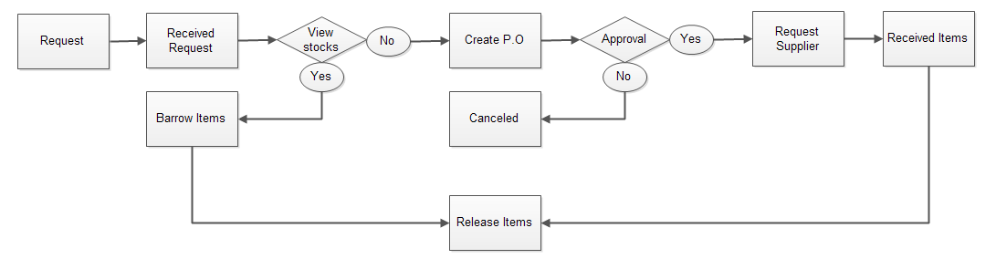

**Common Page**

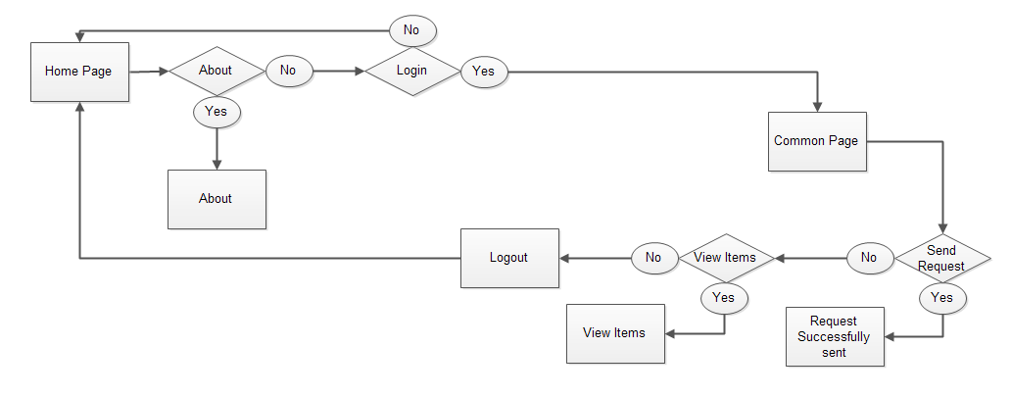

17

**Authorized Page**

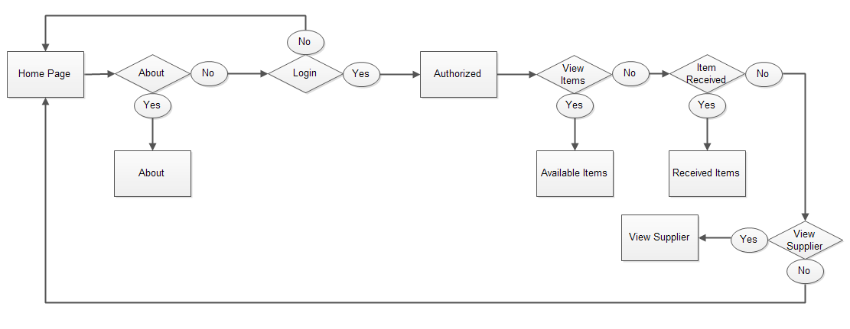

**Admin Page**

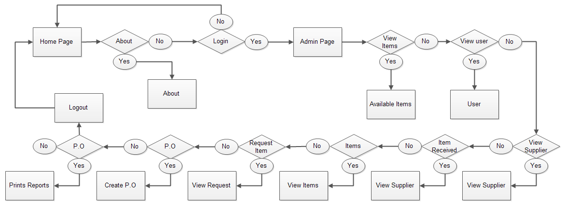

18

**4.8 Database Design**

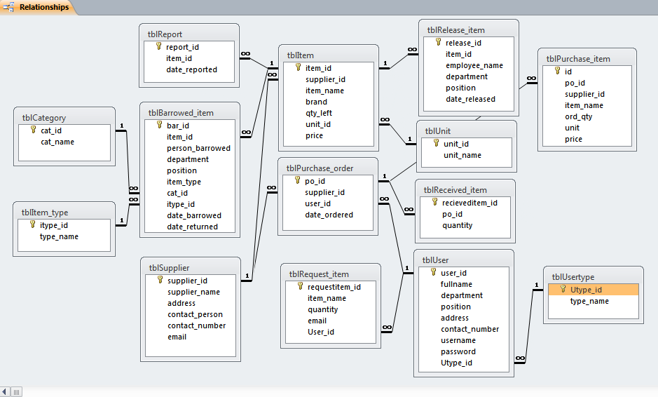

19

**4.9 Data Dictionary**

A data dictionary is a collection of descriptions of the data objects or items in a data model for the benefit of programmers and others who need to refer to them or the dictionary of data is at a time the pillar of work and the result of research and analysis of data. It is just like a depicted picture of the entire work. This dictionary of data defines all categories of data or data types, brief the all essential information about the software is included.

|  |  |  |  |  |  |
| --- | --- | --- | --- | --- | --- |
| **TABLE** | **FIELD** | **DESCRIPTION** | | **TYPE** | **CONTRAINTS** |
| USER | User_id | User identification | | Integer | Primary Key |
|  | Username | Name use by user | | Varchar | Not null |
|  | Password | Password of the user | | Varchar | Not null |
| USERTYPE | Utype_id | Usertypeidentification | | Integer | Foreign key |
|  | Admin | Administrator | | Varchar | Not null |
|  | User | Authorized user | | Varchar | Not null |
| CATEGORY | Cat_id | Category identification | Integer | | Primary Key |
|  | Item_name | Item Identification | number | | Foreign key |
| ITEM | Item_id | Item identification | Integer | | Primary key |
|  | Supplier_id | Supplier Identification | number | | Foreign key |
|  | Item_name | Name of the item | Varchar | | Not null |
|  | Brand | Brand of the item | Varchar | | Not null |
|  | Price | Price of the item | Varchar | | Not null |
|  | Quantity | Quantity of the item | Varchar | | Not null |
|  | Unit_id | Unit identification | Integer | | Foreign key |
|  | Itype_id | Item type identification | number | | Foreign key |
|  | Cat_id | Category identification | number | | Foreign key |
| PO | Purchase_id | Purchase order identification | Integer | | Primary key |
|  | Supplier_id | Supplier identification | number | | Foreign key |
|  | Item_id | Item identification | number | | Foreign key |
|  | Brand | Brand of the item | Varchar | | Not null |
|  | Quantity | Ordered quantity | Varchar | | Not null |
|  | unit | Item unit | Varchar | | Not null |
|  | Price | Item price | Varchar | | Not null |
| UNIT | Unit_id | Unit identification | Varchar | | Primary key |
|  | Unit_name | Name of the unit | Varchar | | Foreign key |
| ITEM TYPE | Itype_id | Item type identification | Varchar | | Primary key |
|  | Type_name | Item type name | Varchar | | Foreign key |
| RECEIVED ITEM | Recieveditem_id | Received item identification | Varchar | | Primary key |
|  | Po_id | Purchase order Identification | Varchar | | Foreign key |
|  | Quantity | Quantity of the received item | Varchar | | Foreign key |
| REPORT | Report_id | Report identification | Varchar | | Primary key |
|  | Item_id |  |  | | Foreign key |
|  | Date_reported |  | Varchar | | Foreign key |
| BARROWED ITEM | Bar_id | Barrowed identification | Integer | | Primary key |
|  | Item_id | Item identification | integer | | Foreign key |
|  | Person_barrowed | Person barrowed the item | Varchar | | Foreign key |
|  | Deparment | Department | Varchar | | Foreign key |
|  | Position | Position of the person | Varchar | | Foreign key |
|  | Item_type | Type of item | Varchar | | Foreign key |
|  | Cat_id | Category identification | integer | | Foreign key |
|  | Itype_id | Item type identification | integer | | Foreign key |
|  | Date_barrowed | Date the item barrowed | Varchar | | Foreign key |
|  | Date-returned | Date the item returned | Varchar | | Foreign key |
| SUPPLIER | Supplier_id | Supplier identification | integer | | Primary key |
|  | Supplier_name | Name of the supplier | varchar | | Foreign key |
|  | Address | Supplier address | varchar | | Foreign key |
|  | Contact_person | Person to be contact | varchar | | Foreign key |
|  | Contact_number | Contact number | varchar | | Foreign key |
|  | email | Supplier email | varchar | | Foreign key |
| REQUEST ITEM | Requestitem_id | Request item identification | integer | | Primary key |
|  | Item_name | Name of the item request | varchar | | Foreign key |
|  | quantity | Quantity of the request item | varchar | | Foreign key |
|  | User-id | User identification | integer | | Foreign key |
| RELEASE ITEM | Release_id | Release identification | integer | | Primary key |
|  | Item_id | Item identification | integer | | Foreign key |
|  | Employee_name | Name of the employee | varchar | | Foreign key |
|  | department | Department of the employee | varchar | | Foreign key |
|  | position | Employee position | varchar | | Foreign key |
|  | Date_released | Date the item released | varchar | | Foreign key |

20

**4.10 Process Specification Format**



Process specification format shows how the specific process begins and where it ends. If the user attempt to login and it is granted the system will let her/him view the main form and the content of it but if he/she fails, the system will go back to the login form.

**4.11 Proposed Implementation Code**

**Database**

A new database is created and SQL code written, defining tables, attributes and relationships.

**HTML**

HTML rather straightforward and it is pretty simple to create a tag or two and throw some text in. It is great to create a online Web page. There’s much more to building a web page than just creating a couple of tags and adding some text.

**CSS (Cascading Style Sheet)**

Once the main structure is ready, CSS code needs to be written to add styles to the application.

**Server-side language**

Implementation of application class, application functions, DB interactions and queries requires a server-side interaction.

**JavaScript**

Implementation of Ajax features (drag and drop, animation effects, etc.) is done using the framework chosen in the Design phase (Query, Scriptaculous, MooTools).

PHP has been employed as a development language and My SQL as a backend database with CSS implemented for the interface having a scope of modification to suit user requirement.

**Chapter V**

**Project Feasibility**

21

**5.1 Technical Feasibilities**

Technical feasibility centers around the existing computer system (Hardware and Software etc) and to what extend it support the proposed addition. For example, if the current computer is operating at 80 percent capacity - an arbitrary ceiling - then running another application could overload the system or require additional Hardware. This involves financial considerations to accommodate technical enhancements. If the budget is a serious constraint, then the project is judged not feasible. In this project, all the necessary cautions have been taken care to make it technically feasible. Using a key the display of text/object is very fast. Also, the tools, operating system and programming language used in this localization process is compatible with the existing one.

**5.2 Economic Feasibilities**

Economic analysis is the most frequently used method for evaluating the effectiveness of the candidate system. More commonly known as cost/benefit analysis, the procedure is to be determining the benefits and savings that are expected from a candidate and compare them with costs. If benefits outweigh costs, then the decision is made to design and implement the system.

A systems financial benefit must exceed the cost of developing that system. i.e. a new system being developed should be a good investment for the organization. Economic feasibility considers the following

* The cost to conduct a full system investigation.
* The cost of hardware and software for the class of application.
* The benefits in the form of reduced cost or fewer costly errors.
* The cost if nothing changes (The proposed system is not developed).

The proposed “ONLINE SUPPLY INVENTORY SYSTEM” is economically feasible because

* The system requires very less time factors.
* The system will provide fast and efficient automated environment instead of slow and error prone manual system, thus reducing both time and man power spent in running the system.
* The system will have GUI interface and very less user-training is required to learn it.

22

**5.3 Operational Feasibilities**

It is the measures of how well a proposed system solves the problems and it takes advantages of the opportunities identified during the scope definition and problem analysis phases. Bukidnon State University Supply Office has computer literate staff so they don’t find it hard to operate the proposed system. However, they need to improve their existing system to more accurate, reliable, secured and well-organized system.

**5.4 Legal Feasibilities**

* Government constrains – since the proposed system is going to be implemented in government institute, it may be subject to Rules and regulation imposed and even funding constrains.
* Copyright issues – Since the proposed system will be using open source software there will be minimal licensing and related issues.

**5.5 Schedule Feasibilities**

The study of the proposed Online Inventory System of Bukidnon State University Supply Office is convenient and sensible to its time frame. Conducting personal interviews with the Supply Officer, creating the documents, designing and developing the software were made to finish the proposal.

**Chapter VI**

**Financial Feasibility and Cost Benefits Analysis**

23

**6.1 EXISTING OPERATIONAL COST** (Supplies and Equipment Annually)

Table 1

|  |  |
| --- | --- |
| **Description** | **Cost** |
| Bond Paper | Php 450.00 |
| Ballpens | Php 150.00 |
| Stapler w/ staple | Php 150.00 |
| Puncher | Php 150.00 |
| Ledger | Php100.00 |
| Paper clip | Php 50.00 |
| Pentel Pens | Php225.00 |
| Cartolina | Php 80.00 |
| Envelope | Php 50.00 |
| Folder | Php 260.00 |
| Refill ink | Php 800.00 |
| Computer | Php 25,000.00 |

**Total = Php 27,465.00**

**6.2 PROPOSED OPERATIONAL COST** (Supplies and Materials)

Table 2

|  |  |  |  |
| --- | --- | --- | --- |
| **Description** | **Price (Php)** | **Quantity** | **Cost** |
| Envelope | Php 20.00 | 2 | Php 40.00 |
| Bond Paper | Php 150.00 | 3 | Php 450.00 |
| Paper clip | Php 3.00 | 15 | Php 50.00 |
| Refill ink | Php 100.00 | 8 | Php 800.00 |
| Computer | Php 25,000.00 | 1 set | Php 25,000.00 |

**Total = Php 26,340.00**

EOP = Existing Operational Cost

POC = Proposed Operational Cost

D = Difference between the EOP and POC

24

**Formula:**

D = EOP – POC

**Computation:**

D = Php 27,465.00 – Php 26,340.00

D = Php 1,125.00

**6.3 ANNUAL BENEFITS AND DEVELOPMENT COST**

For BSU-Alubijid External Studies Center, we have calculated the expenses and benefits and the previous expenses is Php**27, 465.00**. And our proposed expenses are for only **Php 26,340.00.** Assuming an estimated six year operational life of equipment and software, the total benefit would approximate **Php 6,750.00.**

**6.4 PAYBACK PERIOD**

The payback period is the time period required for the amount invested in an asset to be repaid by the net cash outflow from the original investment, and is expressed in years.

The formula for the payback method is simplistic: Divide the cash outlay (which is assumed to occur entirely at the beginning of the project) and divide by the amount of net cash flow generated by the project per year (which is assumed to be the same in every year).

The second invests **Php 26,340.00**in a new system of inventory, and the new system for inventory then produces cash flow of Php**1, 125.00** per year, then the payback period per year is (**Php 26,340.00**initial investment Php**1,125.00** annual payback).

**Appendix A**

25

1. **Summary**

Some institutions are still doing their inventory the old way, the manual process of recording their supplies by paper. It is a time consuming process and could also cause other problems. The upgrading of the existing computerized system into an advance system reduces the time in processing the inventory of the supplies of the school. It can give accurate information in generating reports.

The data that has been collected by the proponents through the interviews and observations that were conducted are summarized below:

* The proponents have discovered that there is no data security and data integrity in their existing system.
* The Supply Officer is having a hard time in updating the inventory records of the school.
* It is time consuming in generating reports.

1. **Conclusion**

The objective of this project was to build a program for maintaining the details of all Supply Order .The system developed is able to meet all the basic requirements. It will provide the facility to the user so that they can keep tracks of all the equipment being supplied. The management of the Inventory will be also benefited by the proposed system, as it will automate the whole supply procedure, which will reduce the workload. The security of the system is also one of the prime concerns.

There is always a room for improvement in any software, however efficient the system may be. The important thing is that the system should be flexible enough for future modifications. The system has been factored into different modules to make system adapt to the further changes. Every effort has been made to cover all user requirements and make it user friendly.

26

**Goal achieved:** The System is able provide the interface to the user so that he can replicate his desired data.

**User friendliness:** Though the most part of the system is supposed to act in the background, efforts have been made to make the foreground interaction with user as smooth as possible. Also the integration of the system with Inventory Management project has been kept in mind throughout the development phase.

1. **Recommendation**

Future studies should look at the opportunity of implementing a standard procedure for the procurement method as applied in the industry with view minimizing waste in inventory. Other issues that can be further discussed are the ability to integrate the system into faculty website, providing more accessibility to the teachers, students and visitors to acknowledge the inventory status. Also, better strategies are to devised for the faculty and staffs so that a more feasible procedure is followed in the procurement practices.

1. **Definition of Terms**

* **Inventory**- is the process of making an itemized list of supplies on hand.
* **Inventory system**- is the system of recording the properties of the school in supply office
* **Faculty’s information**- faculty’s background
* **Data loss**-refers to the unforeseen loss of data or information.
* **Data Security**- extrusion prevention is the practice of stopping data leakage by filtering outbound network traffic. The practice protects sensitive digital assets from unauthorized transfer by stopping the movement of packets across the network. Extrusion detection, by contrast, simply alerts an administrator to a potential issue.
* **Data Integrity**- refers to the validity of data, meaning data is consistent and correct.

27

**Bibliography**

<http://www.netmba.com/operations/project/pert/>

<http://www.sourcecodester.com/php/4481/simple-inventory-system-using-phpmysql.html>

<http://en.wikipedia.org/wiki/Database_design>

<http://database-programmer.blogspot.com/2008/06/using-data-dictionary.html>

<http://osarome.blogspot.com/2011/10/1-technical-feasibility-2-operational.html>

<http://www.ganttchart.com/BasicGanttExample.html>

1. **Interview Questions**

* What are the common problems in making an inventory?
* What kind of system or software you usually used?
* How big is your operational cost?
* How many personnel perform during the inventory activity?
* What are those materials did you used when you having an inventory?

**Appendix B**

28

1. **TIME TABLE**

|  |  |  |
| --- | --- | --- |
| **Activity** | **Detailed activity** | **Days required** |
| Data gathering | Conduct interviews | 3 |
|  | Survey/questioners | 4 |
|  | Read supply office reports and information | 3 |
|  | Introduce web based system | 5 |
|  | Observed reaction to the propose system | 4 |
|  |  |  |
| Data flows and decision analysis | Analyze data flow | 24 |
|  | Designing database | 18 |
|  | Data dictionary | 6 |
|  | Entity relationship | 10 |
|  | Analyze system requirements | 12 |
|  |  |  |
| Proposal preparation | Perform cost and benefits analysis | 11 |
|  | Prepare recommendation | 4 |
|  | Prepare proposal | 4 |

1. **GANTT CHART**

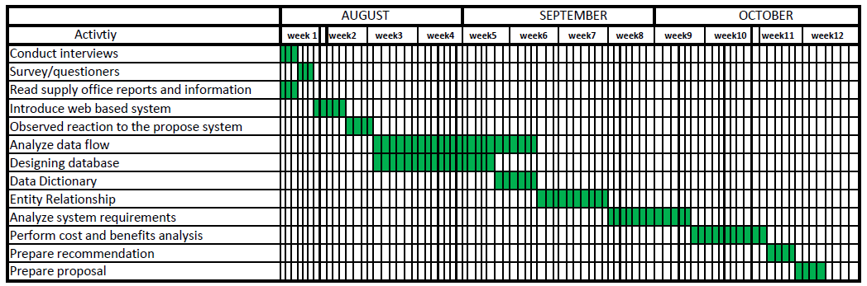

29

1. **PERT DIAGRAM**



30

1. **FLOWCHART**

**Main Page flowchart**



The main page flow chart shows all the choices that the user can choose from. To start the system flow the user must logged in first before he/she can enter or access the system. When the user finishes typing her username and password, then he/she can click the login button to access the main page. But if he/she fails to login or his/her username or password is incorrect, he/she will stay in the login page and he/she cannot access to the main page.

31

**Login flowchart**



The login flowchart shows the process when the user enters her username together with her password. After the user inputted his/her username and password, the system will check if those username and password inputted correct/incorrect or if it is exists, if not then the system will ask again for the correct username and password. If username and password exists, then the user can access the main page and perform different transactions.

32

**User Entry flowchart**

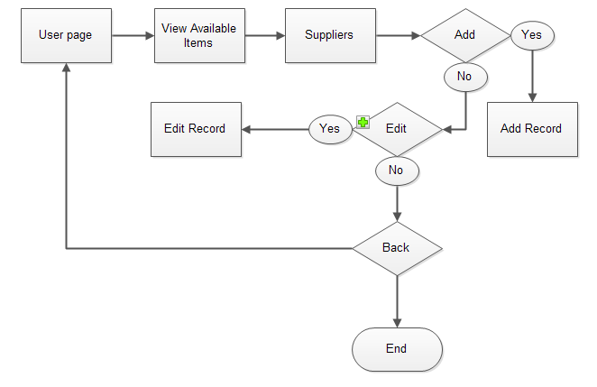

If the user is already in the user page, he/she can view the list of all available items in the table and no the actions will display, and in the suppliers navigation he/she can choose whatever action he/she wants to perform. And after viewing all the items the users may now exit or logout after he/she finished what he’ll/she’ll done.

33

**Supplier Entry flowchart**



Also in the supplier entry flowchart, he/she can choose or click the supplier entry navigation and the table and all the actions will display, and he/she can choose whatever action he/she wants to perform. And the back button let the user go back to the main page after he/she finished what he’ll/she’ll done.

34

**Stocks Entry flowchart**

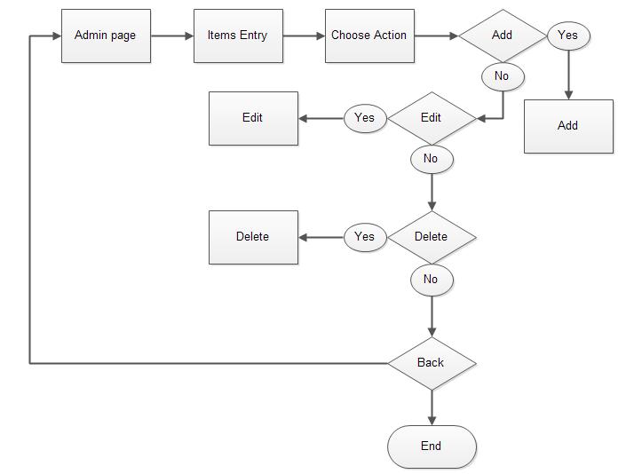

Also in the items entry flowchart, he/she can choose or click the items entry navigation and the table and all the actions will display, and he/she can choose whatever action he/she wants to perform.

35

1. **SCREENSHOTS**

**LOGIN FORM**

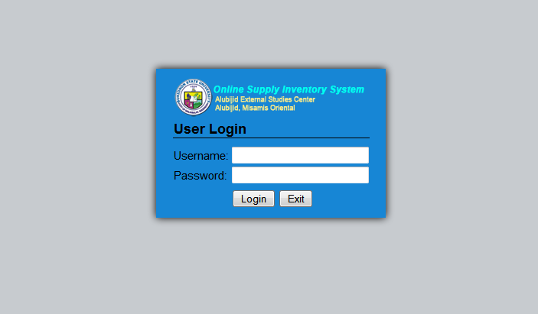

36

**Home Page**

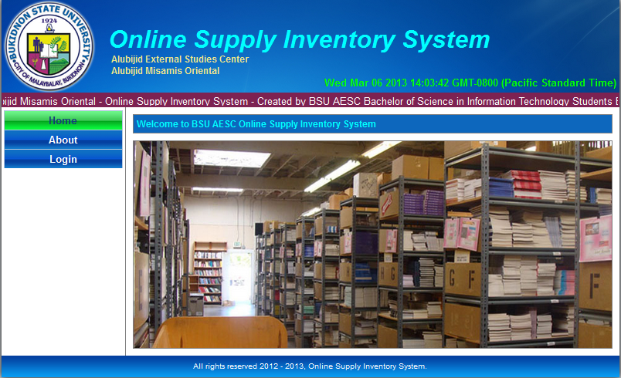

**37**

**ADMIN PAGE**

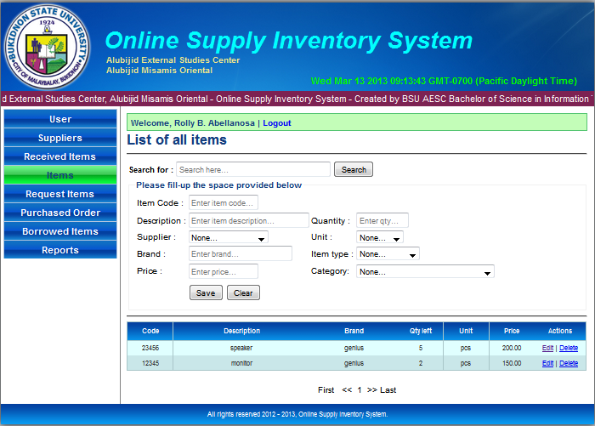

**38**

**AUTHORIZED PAGE**

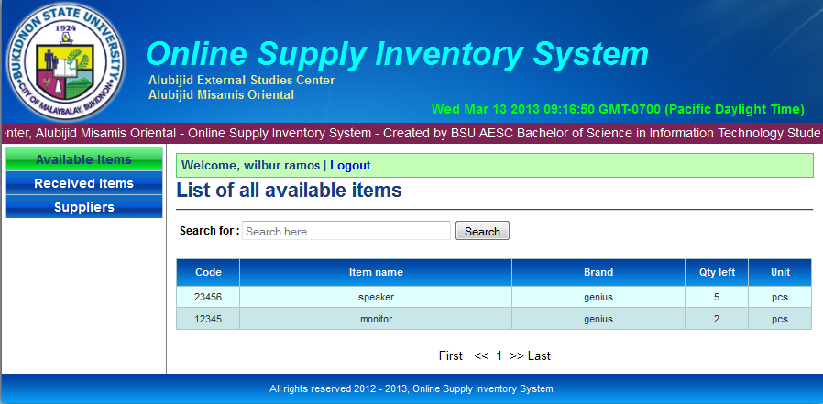

**COMMON PAGE**

